**GRAPHIC DESIGN**

*GOOD DESIGN*

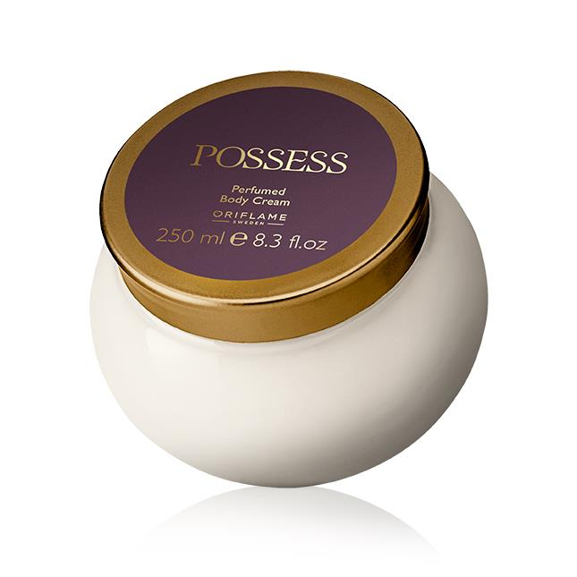

*REASONS*

* Honest –shows or tells exactly what the consumer should expect from the product and nothing more. (not biased).
* Aesthetic-the photo or product design compels the consumer.
* Long lasting-withstands trends; the ever changing market and customer preference.

*Good design*

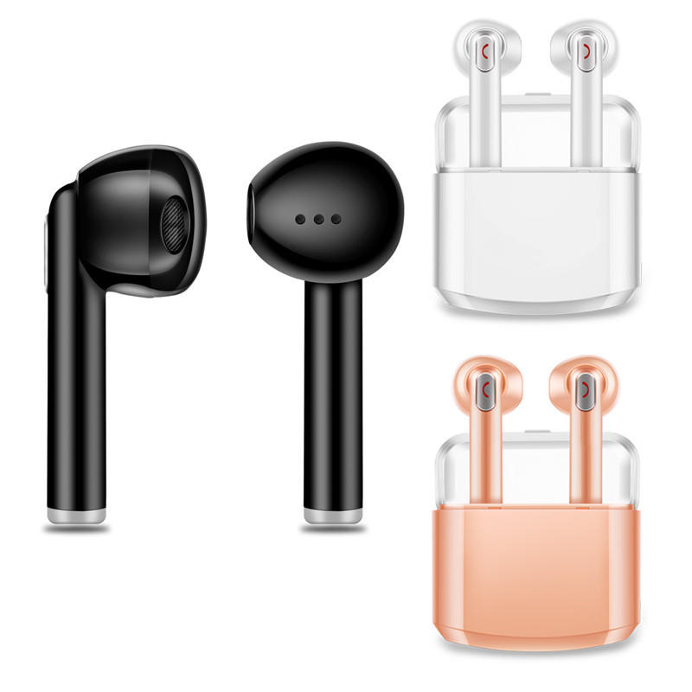

*Reasons*

* **Simple –less is more.**
* **Innovative-pushes our understanding of the product forward.**
* **Long lasting-withstands trends.**

*Good design*

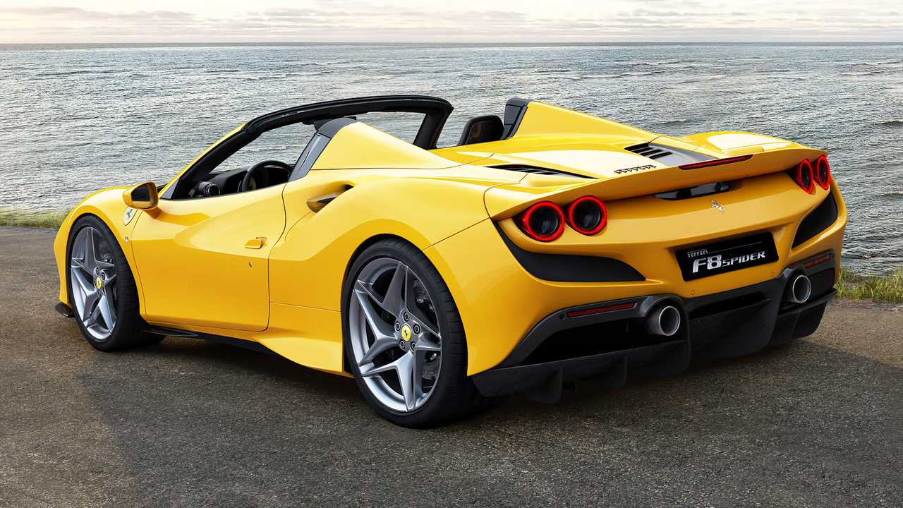

*Reasons*

* *Aesthetic- the photo or design of the product compels the consumer to purchase it.*
* *Beauty-pretty and functional.*
* *Makes the product useful-people define their self image through their possessions for instance if a person owns a Ferrari car,apple iphone.The product defines them as rich.*

*Bad design*

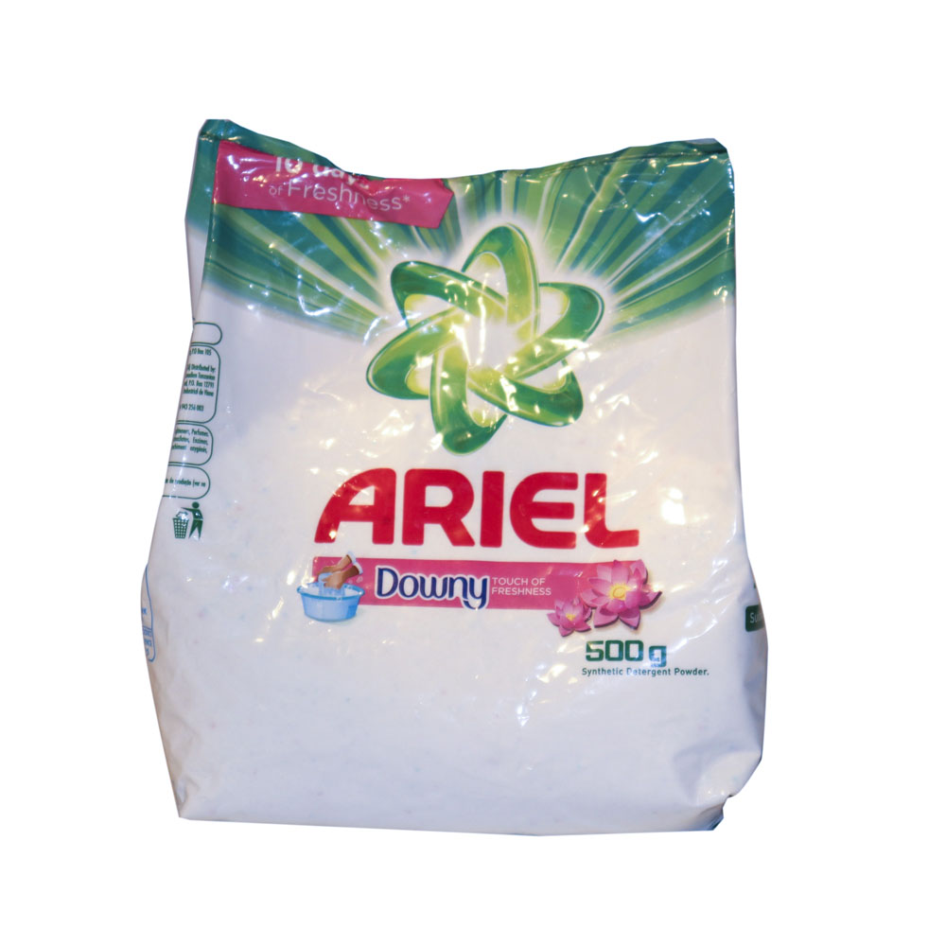

*Reasons*

* *Not aesthetic -the product is unappealing.*
* *Biased-over illustrates on the effeciancy of the product.*
* *Not long lasting-can’t withstand the ever changing market.*

*Bad design*

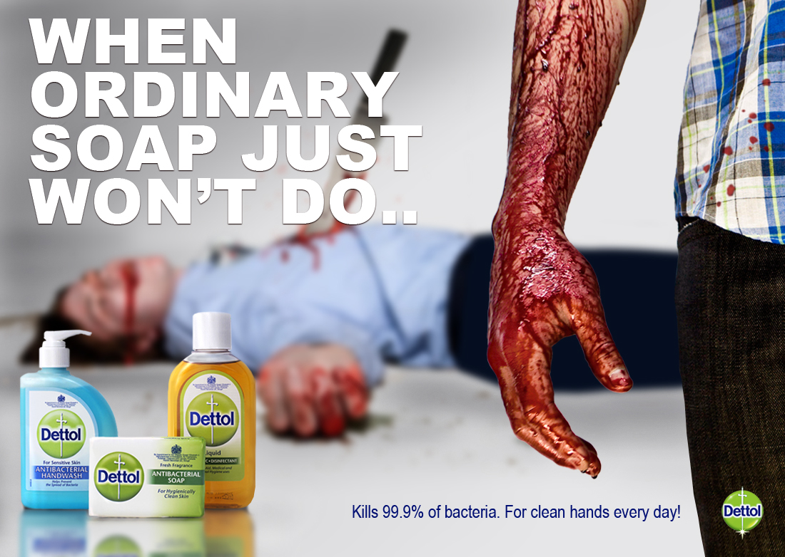

*Reasons*

* *Contradicting-what kind of message are they conveying.*
* *Unappealing-it is upsetting to look at advert.*
* *Not innovative*

*Bad design*

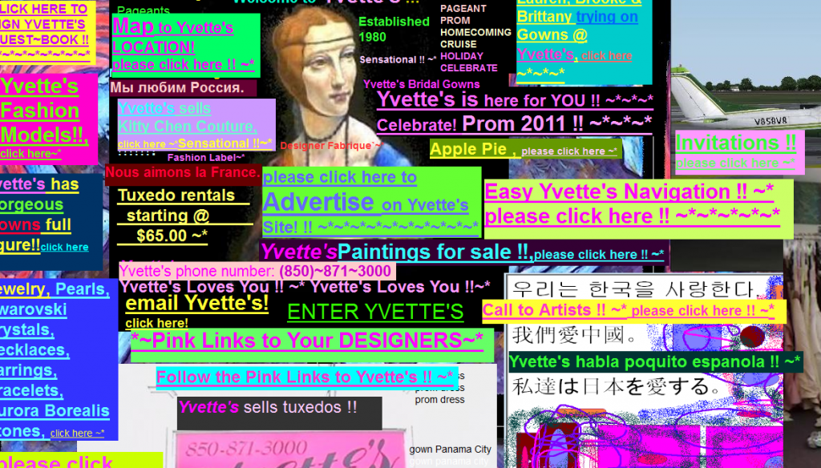

*Reasons*

* *Use of many colors and fonts-colors are loud and obtrusive to user interface.*
* *No visual hierarchy-there’s so much going on and it’s distracting.*
* *Lack visual direction-confuses on where to direct your focus.*
* *Lack of stracture -the ideas haven’t been outlined in systematic manner.*